AWS Task-3

- Create a S3 bucket, with no public access and upload files to the bucket & view the logs using cloudwatch for the uploaded files.

Created S3 bucket as follows,

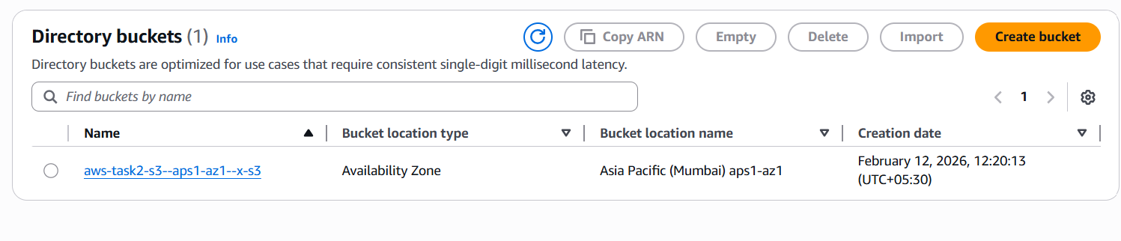

Uploaded 2 files in the Bucket

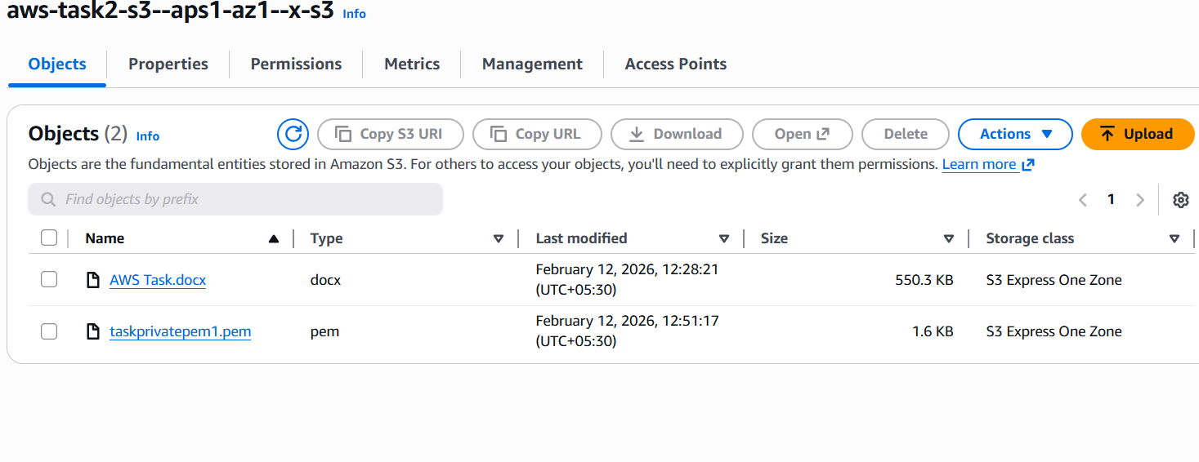
Created Cloudtrial with Cloud watch log enabled

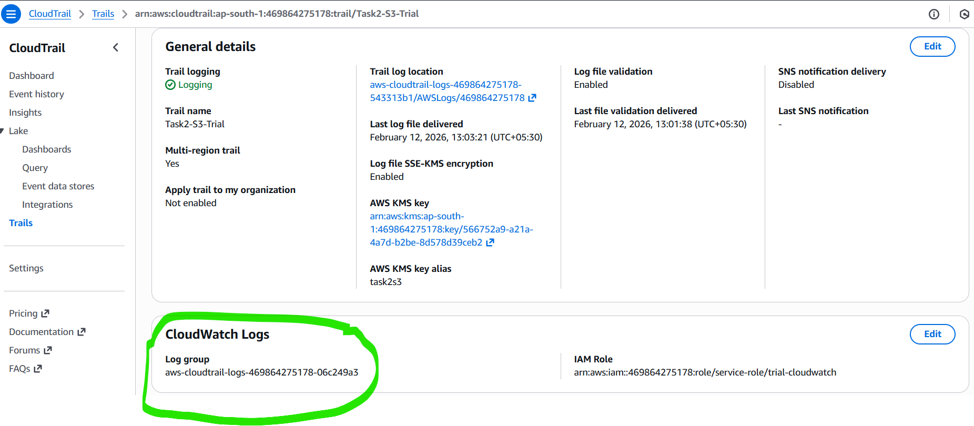

From Cloudwatch can see my log group that created in Cloud Trial

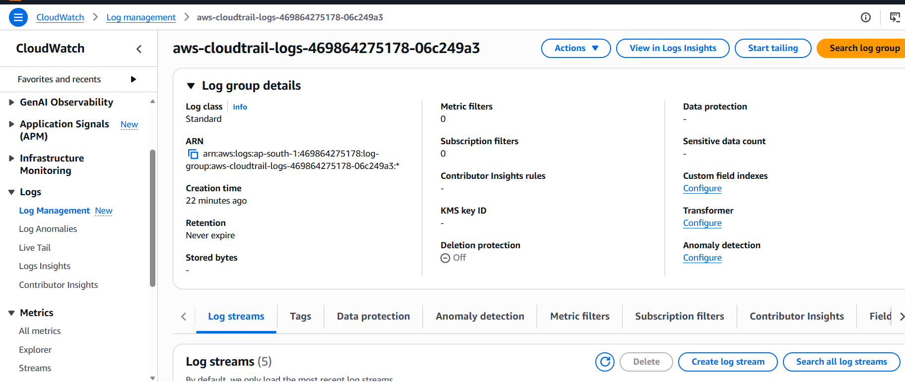

Output : Viewing logs from Cloud watch

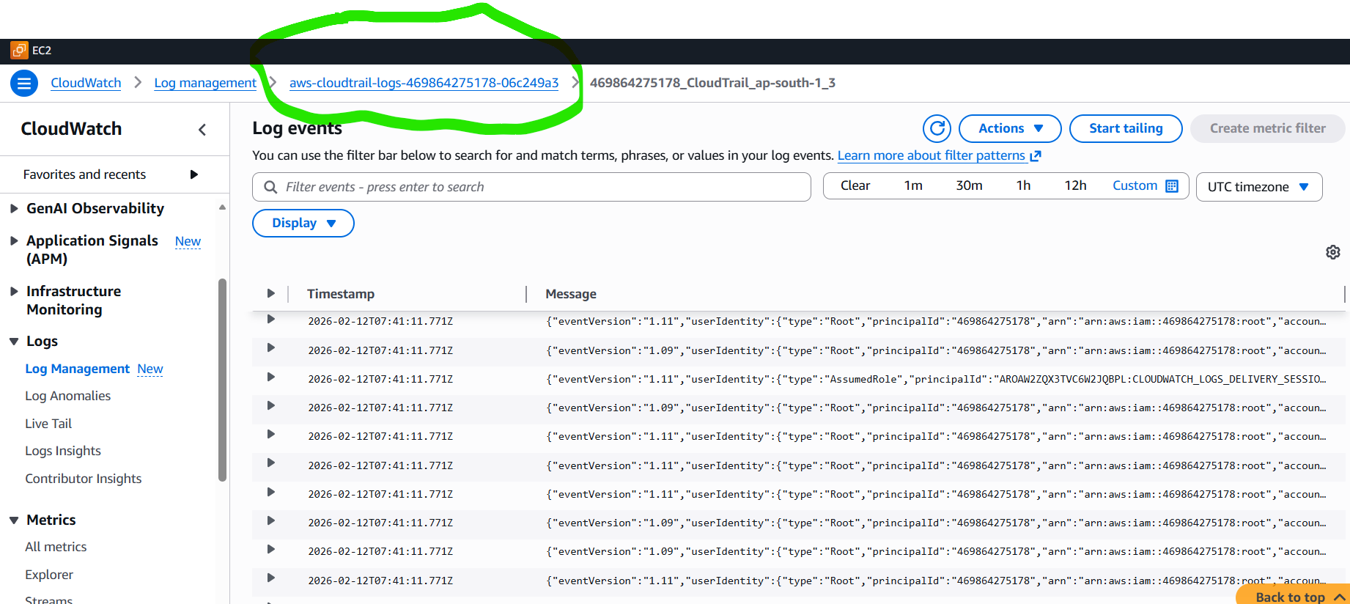

- Launch two ec2-instances and connect it to a application load balancer, where the output traffic from the server must be an load balancer IP address

Created Application load balancer

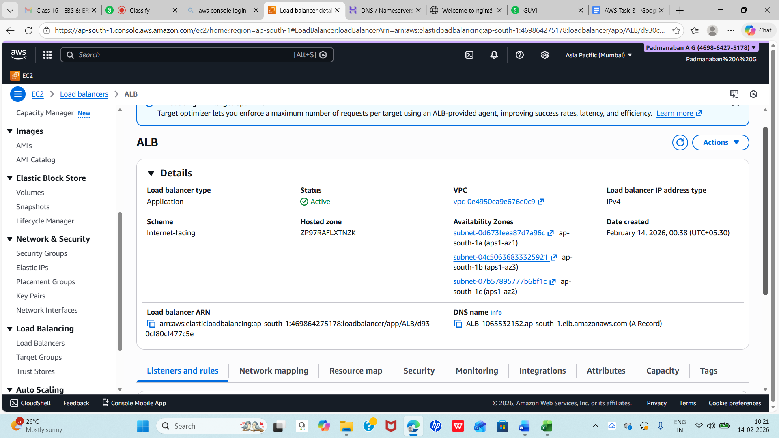

Created Rules to load balance

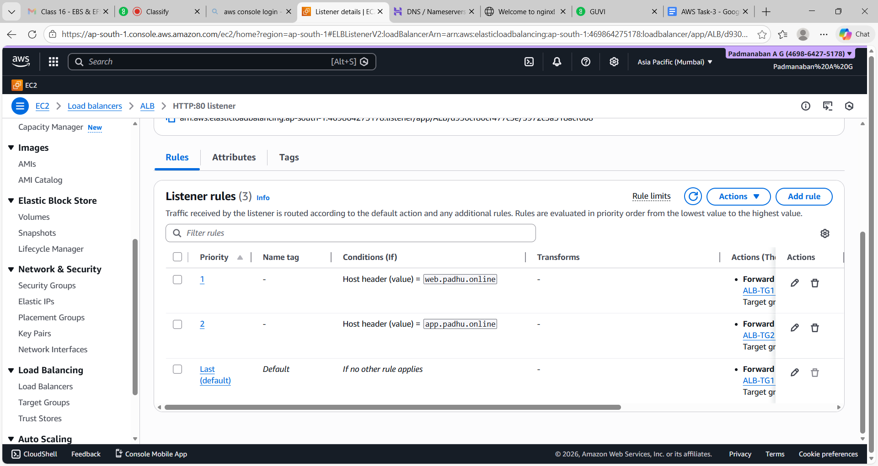

Created DNS nameserver with my own domain padhu.online

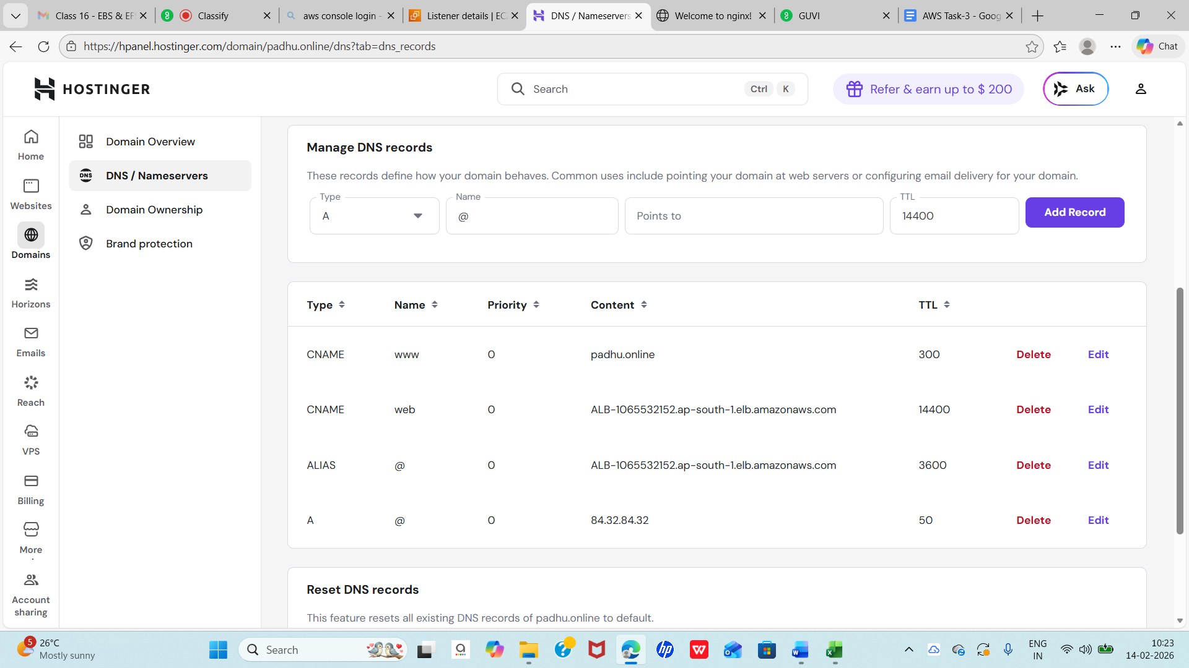

Working with my domain with Application Load Balancer
